**ONLINE ARTS GALLERY**

**TEAM MEMBERS:**

**NITYASREE.P 17MIS1007**

**MALAVIKA.P.S 17MIS1080**

**ABSTRACT:**

**Art enables us find ourselves and lose ourselves at the same time. Arts Online Art Gallery showcase artworks from realism to impressionism to abstraction in the plain-air, landscape, still-life, western and sculpture genres and also art works ranging from Mural Paintings to Modern Contemporary Art to Abstract Art. Thus this online art gallery will help you in buying and selling the most marvellous paintings.**

**INTRODUCTION:**

**An online art gallery is a website that display artworks. Usually, the online gallery is run as a business, with the purpose of displaying the artwork being to promote it to potential buyers. Other variations include:**

* **The online art gallery displaying art work from their current, future, or past exhibitions, most often to promote the exhibitions, rather than with a view to selling the work via the website .**
* **The online art gallery is developed using concepts of HTML,JAVASCRIPT,PHP.**

**The details of the users are used in the database by using xampp and retrieved by using php.**

**PROJECT MOTIVE:**

* **Online Art gallery management system is an application that allows buyers to purchase paintings online. The purchase is just a click away, you don’t have to go to some old museums and buy from selected stuff.**
* **You can sell your artistic works if you wanted to earn money and this forum will give nice exposure to users.**

**MODULES:**

**1.REGISTER**

* **Enter the name,username,email id,date of birth,gender,designation,mobile,create password and confirm password .**
* **if create and confirm password didn’t match the field becomes red else it becomes green.**
* **All the fields mentioned here are mandatory.**
* **Submit button takes to registration confirmation module.**

**Concepts used: form validation using javascript and php**

* 1. **Register confirmation**
* **Name ,username,phone and mail is shown for confirmation and on submitting it we can go to login page**

**concepts used: php post**

**2.LOG IN**

* **Username and password is entered if it matches with the details in database we can go to online art gallery homepage**

**Concepts used: form validation with data stored in database**

**3. online art gallery Home page**

**Home**

**About**

**Buyart**

**Sellart**

**Contact**

**logout**

**Concepts used: css,html links**

**4.buy art section home page:**

**Art can be sold by uploading the images and by giving contact details**

**Concepts using: javascript ,html,php database connection**

**4.1 about us**

* **It tells about the arts gallery and Online Art gallery management system is an application that allows buyers to purchase paintings, scriptures, models online. The purchase is just a click away, you don’t have to go to some old museums and buy from selected stuff.**

**Concept:**

* **Html paragraph,lists,tables,images .**

**4.2 contact us:**

* **Can contact the online art gallery development people and can take help of them about the selling and buying of art**
* **Concepts: html image,tables,,frames**

**5.logout the webpage**

**After the completion of the selling or buying the arts then logout of the webpage and then come backs to login page .**

**Concept used: php,html**

**RESULTS:**

**LOGIN /REGISTER**

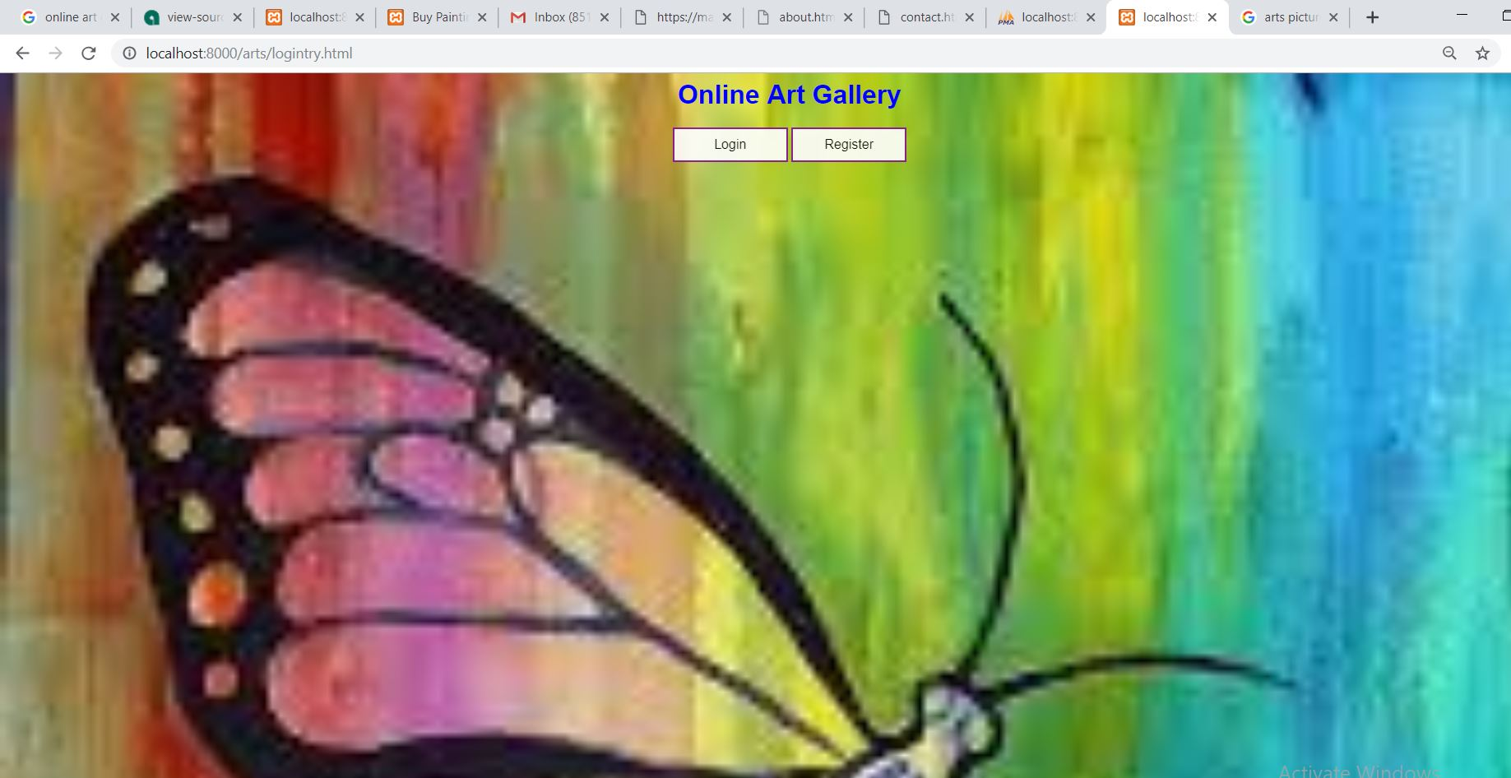

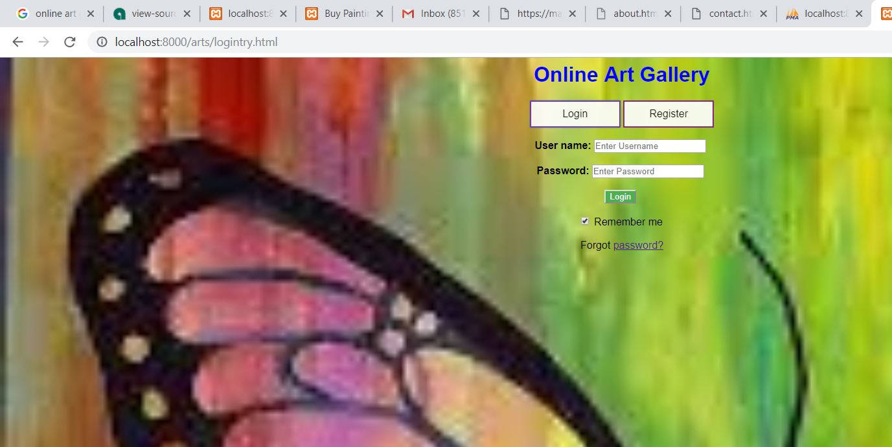

**REGISTER**

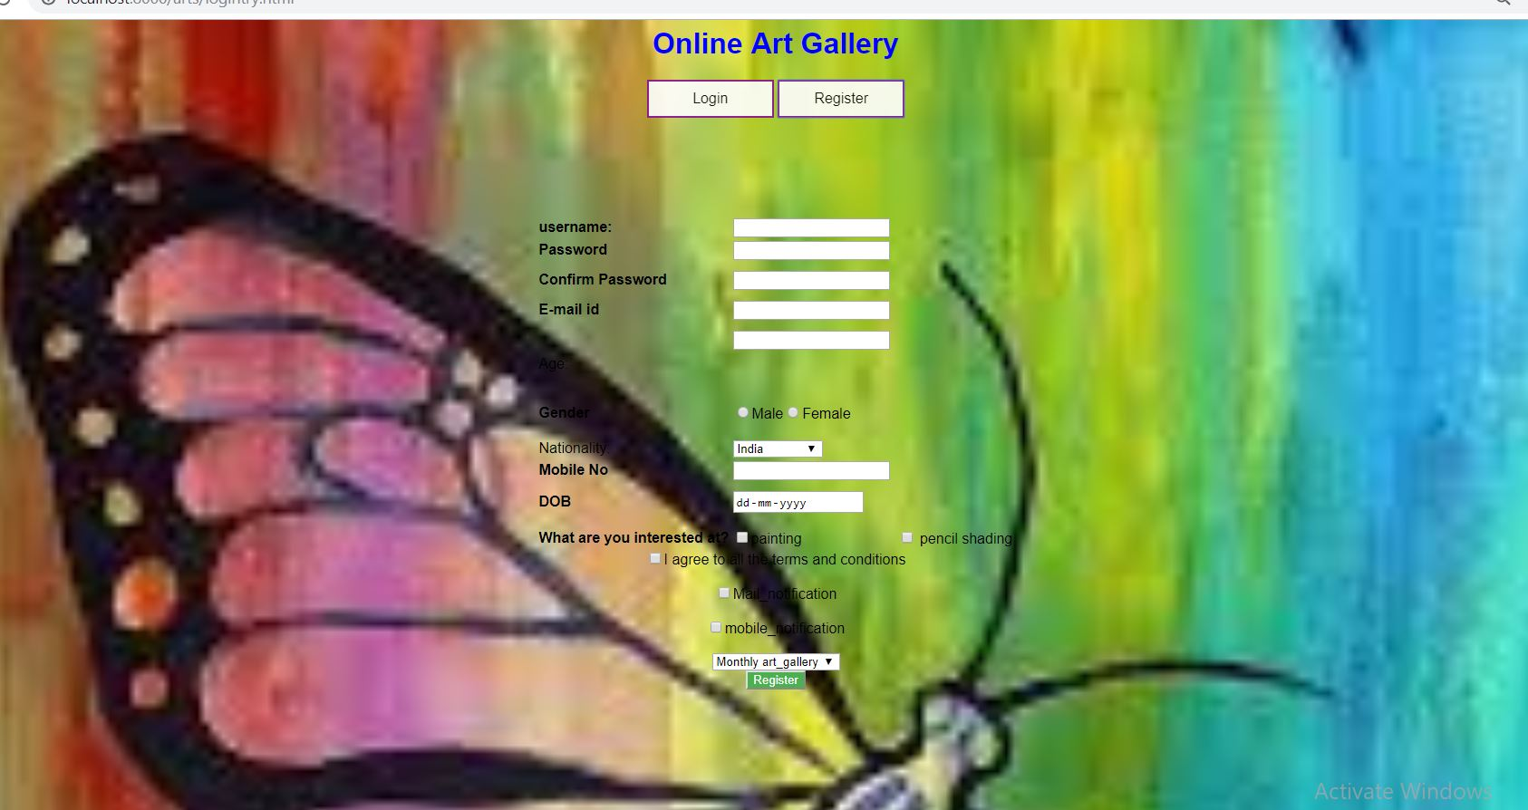

**WHEN ANY THING IS NOT FILLED**

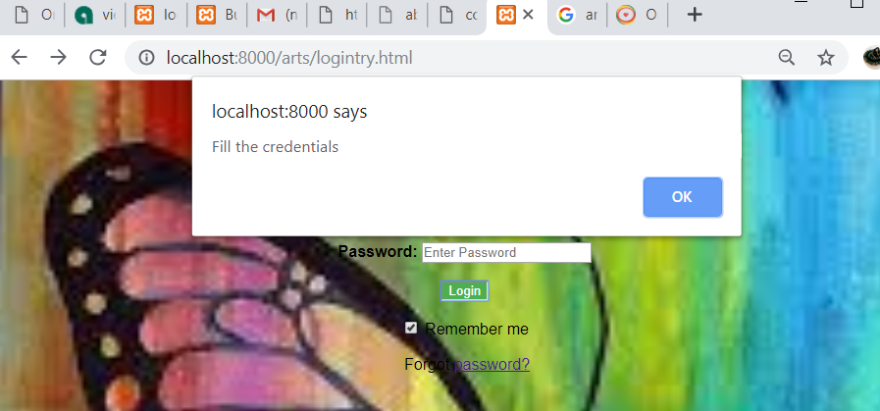

**WHEN SUBMIT IS CLICKED**

**LOGIN :**

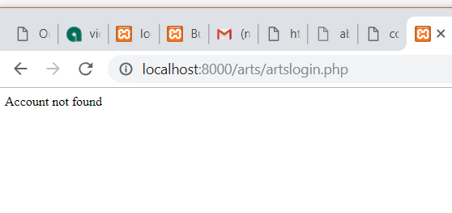**WRONG PASSWORD**

**RIGHT PASSWORD**

**Arts gallery HOME PAGE**

**ARTS SECTION IN NAVIGATION BAR**

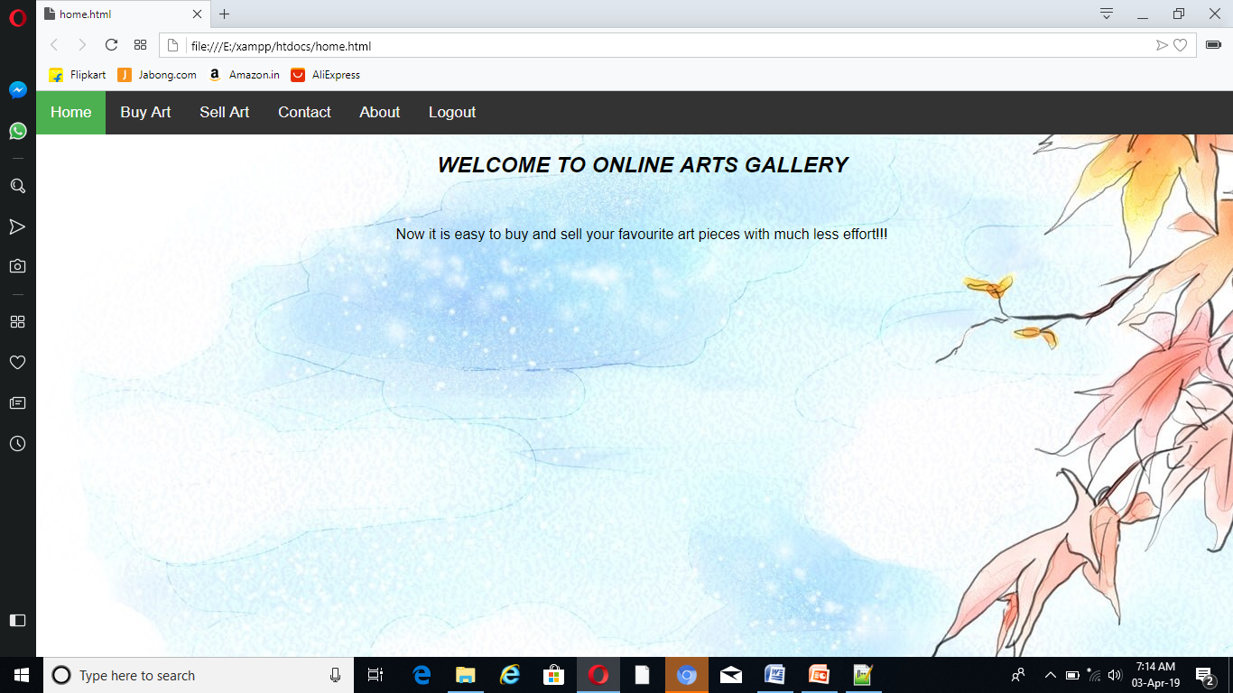

**WHEN MAIL IS SENT**



**CONTACT USING FRAMES**

**P1.html**

<html>

<head>

<title>ORIGINAL ART</title>

<body background="C:\Users\pc\Documents\i1.jpg">

<h1><center> THIS IS ORIGINAL ART</center> </h1>

<p>Great art piece from the established and emerging Indian & International

artist with authentication certificate</p>

</body>

</head>

</html>

**P4.html**

<html>

<head>

<title>ART ADVISORY</title>

<style>

body{

background-repeat:no-repeat; background-size:cover;

}

</style>

<body background="C:\Users\pc\Documents\i4.jpg">

<h1><center> This is ART ADVISORY</center> </h1>

<p>You can always take the help of our expert team to pick the perfect art

matching your requirements for art investment, decor, gifting</p>

</body>

</head>

</html>

**P5.html**

<html>

<head>

<title> CONTACT DETAILS</title>

<body background="C:\Users\pc\Documents\i5.jpg">

<h1><center> MOBILE NO AND EMAIL ID</center> </h1>

<p>9043204022</p>

<p1>artgallery@gmail.com</p1>

</body>

</head>

</html>

P6.html

<html>

<head>

<title>ROLL OR FRAME,SPECIAL PACKAGING</title>

<body background="C:\Users\pc\Documents\i6.jpg">

<h1><center> This is ROLL OR FRAME ,SPECIAL PACKAGING </center> </h1>

<p>We ship painting in rolled form. Framing can be done on request.

Multiple framing options are available on request</p>

</body>

</head>

</html>

**P2.html**

<html>

<head>

<title>WORLDWIDE SHIPMENT</title>

<body background="C:\Users\pc\Documents\i2.jpg">

<h1><center>WORLDWIDE SHIPMENT </center> </h1>

<p>Shipping is free in India and charged depending on your location</p>

</body>

</head>

</html>

**P3.html**

<html>

<head>

<title>COMISSION AN ART MASTERPIECE</title>

<body background="C:\Users\pc\Documents\13.jpg">

<h1><center> COMISSION AN ART MASTERPIECE </center> </h1>

<p>Looking for something very different? We can get a work commissioned for you depending on your requirement</p>

</body>

</head>

</html>

<html>

<frameset cols="35%,35%,*">

<frameset rows="*,*">

<frame name="f1" src="p1.html"></frame>

<frame name="f2" src="p2.html"></frame>

</frameset>

<frameset rows="*,*">

<frame name="f2" src="p3.html"></frame>

<frame name="f2" src="p4.html"></frame>

</frameset>

<frameset rows="*,*">

<frame name="f2" src="p5.html"></frame>

<frame name="f2" src="p6.html"></frame>

</frameset>

</frameset>

</html>

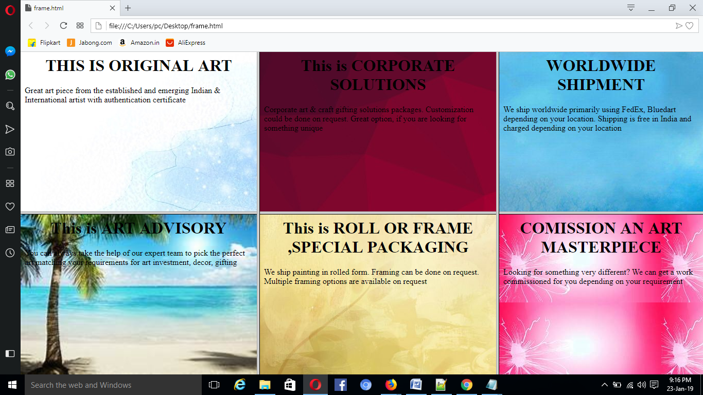

**TO BUY THE ART IN GALLERY:**

?php  
  
  
$db = mysqli_connect("localhost","root","","photos");  
  
  
$sql="SELECT*FROM images";  
$result=mysqli_query($db,$sql);  
  
while($row=mysqli_fetch_array($result))  
{  
echo"<div id='img_div'>";  
  
echo"<img src='".$row['image']."'>";  
echo"<p>".$row['text']."</p>";  
}  
$conn->close();  
?>

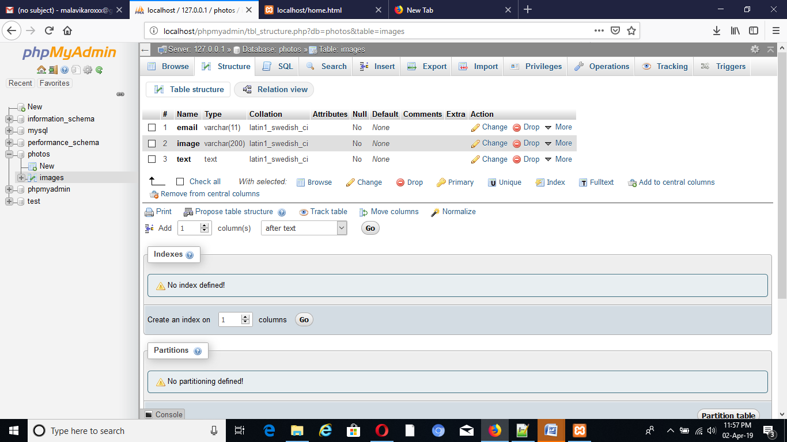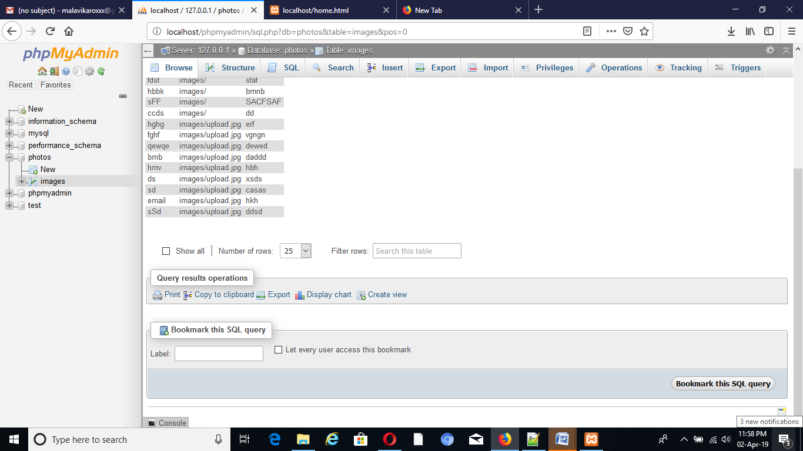**DATABASE CONNECTION TO BUY AND SELL ART**

**TO SELL ART IN GALLERY**

<html>  
<head>  
<title>upload your art</title>  
</head>  
<body>  
<div id="content">  
  
<form method="post" action="up.php" enctype="multipart/form-data">  
<div>  
<input type="text" name="email">  
</div>  
<div>  
<input type="file" name="upload">  
</div>  
<div>  
<textarea name="text" cols="40" rows="4" placeholder="give your contact details and price about your art.."></textarea>  
</div>  
<div>  
<input type="submit" name="upload" value="upload image ">  
</div>  
</form>  
</div>  
</body>  
</html>

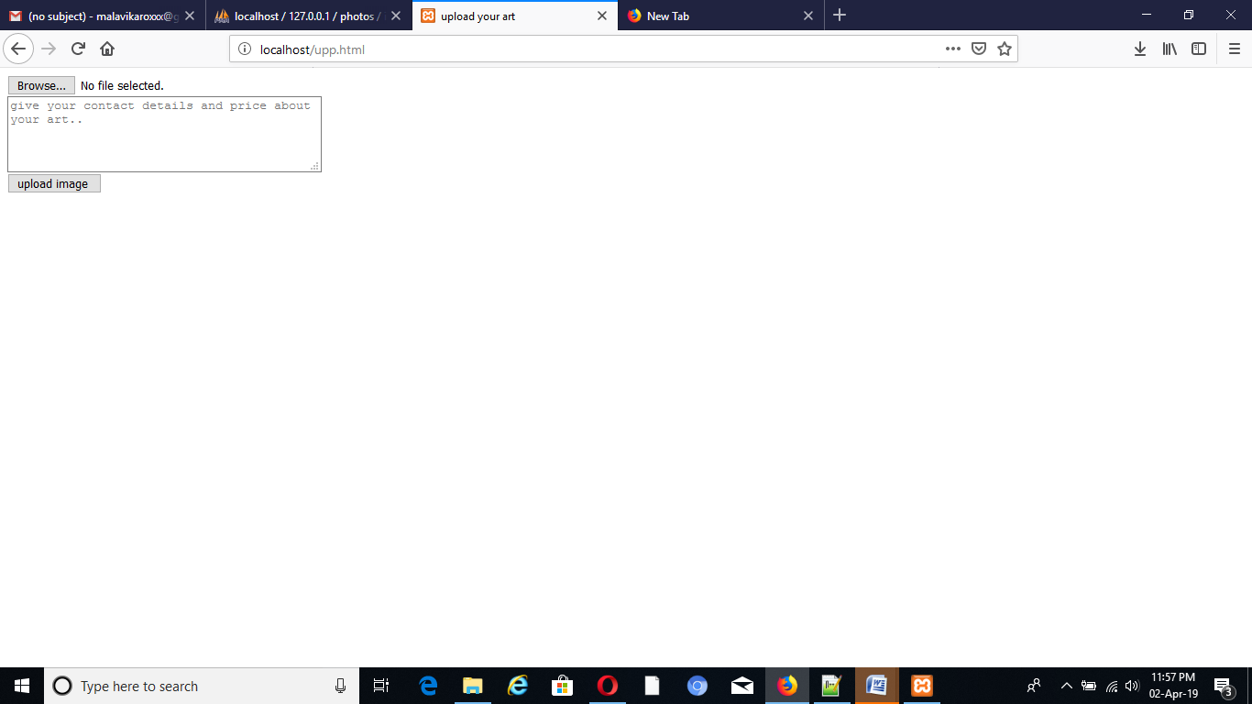

**MODULES: LOGIN ENRTY CODE:**

<html>

<head>

<h1 align="center"><font color="blue" >

Online Art Gallery</font>

</h1>

<meta name="viewport" content="width=device-width, initial-scale=1">

<style>

body{background-image: url("img1.jpg");

background-repeat: no-repeat;

background-size: cover;

}

div{

display: none;

position: middle;

bottom: 0;

right: 15px;

z-index: 8;

}

body {font-family: Arial, Helvetica, sans-serif;}

* {box-sizing: border-box;}

/* Button used to open the contact form - fixed at the bottom of the page */

.buton {

background-color: #890F90;

color: white;

padding: 10px 24px;

border: none;

cursor: pointer;

opacity: 0.9;

position: middle;

top: 25px;

left: 100px;

width: 140px;

font-size: 16px;

-webkit-transition-duration: 0.4s; /* Safari

transition-duration: 0.4s;*/

}

.buton {

background-color: white;

color: black;

border: 2px solid #890F90;

}

.buton:hover {

background-color: #890F90;

color: white;

}

/

.bt:hover {

background-color: white;

color: black;

border: 2px solid #4CAF50;

}

.bt {

background-color: #4CAF50;

color: white;

}

/* Add some hover effects to buttons */

/*.form-container .btn:hover, .open-button:hover {

opacity: 1;

}*/

</style>

</head>

<button class="buton" onclick="logForm()" >Login</button>

<button class="buton" onclick="regForm()" >Register</button><br><br>

<body align="center" >

<div class="form-container" id="myForm" >

<form name="log" action="artslogin.php" onsubmit="return validateForm()" method="POST">

<b>User name:</b>

<input type="text" name="name" size=20 placeholder="Enter Username">

<br>

<br>

<b> Password:</b>

<input type="password" name="password" size=20 placeholder="Enter Password">

<br>

<br>

<!--<button onclick="location.href='fv.html'" type="button">Register</button>-->

<button type="submit" class="bt">Login</button>

<br>

<br>

<input type="checkbox" checked="checked" name="remember"> Remember me

<br>

<br>

Forgot <a href="#">password?</a><br>

</form>

</div>

<div id="md" class="form-container">

<form align="center" name="md" onsubmit="return validation()"action="reg.php" method="POST">

<table align="center">

<tr>

<td><b>username:</td>

<td><input type="text" name="fname" onkeypress="return(event.charCode>64

&& event.charCode<91)||(event.charCode>96 && event.charCode<123)" >

</td>

<tr>

<td><b>Password</b> </td>

<td> <input type="password"name="password"size="20"></td>

</tr>

<tr><td></td></tr>

<tr><td></td></tr>

<tr>

<td> <b>Confirm Password </b></td>

<td> <input type="password"name="cpass"onblur="passw()"size="20"> </td>

</tr>

<tr><td></td></tr>

<tr><td></td></tr>

<tr>

<td><b>E-mail id </b></td>

<td> <input type="email" name="email" size="20"required></td>

</tr>

<tr><td></td></tr>

<tr><td></td></tr>

<tr>

<td>

Age: </td>

<td>

<input type="number" name="age"/> <br><br><br><br></input>

</td>

</tr>

<br>

<tr>

<tr>

<td> <b>Gender</b> </td>

<td> <input type="radio"name="gender"value="male">Male<input type="radio"name="gender"value="female">Female</td>

</tr>

<tr><td></td></tr>

<tr><td></td></tr>

<tr><td></td></tr>

<tr><td></td></tr>

<tr>

<td> Nationality:</td>

<td> <select name="Nationality" id="eg">

<option value="India">India</option>

<option value="Pakistan">Pakistan</option>

<option value="Bangladesh">Bangladesh</option>

</select>

</td>

</tr>

<br>

<tr>

<td><b>Mobile No</b></td>

<td> <input type="number"name="phoneno"size="20"></td>

</tr>

<tr><td></td></tr>

<tr><td></td></tr>

<tr>

<td><b>DOB</b></td>

<td><input type="date" name="dob"size="20"></td>

</tr>

<br>

<td><tr>

<tr><td></td></tr>

<tr><td></td></tr>

<tr>

<td><b>What are you interested at?</td>

<td><input type="checkbox" name="notification" value="painting">painting

</td>

<td><input type="checkbox" name="notification" value="pencil shading">

pencil shading</td>

<br>

<br>

</table>

<input type="checkbox" name="k">I agree to all the terms and conditions<br>

<br><input type="checkbox" name="kl">Mail_notification<br>

<br><input type="checkbox" name="kll">mobile_notification<br><br>

<select name=subscription>

<option value="a">Monthly art_gallery</option>

<option value="b">weekly art_gallery</option></td></tr>

</select><br>

<tr>

<td align="center"> <button type="submit" class="bt">Register</button></td>

</tr>

</form>

</div>

<script>

function validateForm() {

var x = document.forms["log"]["name"].value;

var y = document.forms["log"]["password"].value;

if(x=="" && y==""){

alert("Fill the credentials");

return false;

} else if (x == "") {

alert("username must be filled out");

return false;

}

else if (y == "") {

alert("Password must be filled out");

return false;

}

}

function logForm() {

document.getElementById("myForm").style.display = "block";

document.getElementById("md").style.display = "none";

}

function regForm() {

document.getElementById("md").style.display = "block";

document.getElementById("myForm").style.display = "none";

}

function passw()

{

var d=document.md.pass.value

var e=document.md.cpass.value

if(d==""){

alert("Password must be filled")

return false}

else if(e==""){

alert("Confirm Password should be filled")

return false}

else if(e!=d){

document.md.cpass.style.backgroundColor="red"

alert("Password does not match")

return false}

else if(e==d){

document.md.cpass.style.backgroundColor="green"

}

}

function validation()

{

var a=document.md.n.value

var b=document.md.gender.value

var c=document.md.num.value

var d=document.md.loc.value

if(a==""){

alert("Name must be filled")

return false}

else if(b==""){

alert("Select a Gender")

return false}

else if(c==""){

alert("Enter a valid Mobile number")

return false}

else if(c.length!=10){

alert("Enter a valid Mobile number")

return false}

else if(c==""){

alert("Enter your College name")

return false}

else if(d==""){

alert("Enter your location")

return false}

}

</script>

</body>

</html>

**REGISTERFORM -CONNECTON CODE:**

<?php

$con=mysqli_connect('localhost','root','','gallery');

if(!$con)

echo 'connection error';

$na=$_POST['name'];

$pas=$_POST['password'];

$em=$_POST['email'];

$gen=$_POST['gender'];

$mob=$_POST['phoneno'];

$da=$_POST['dob'];

$sql="INSERT INTO users(name,password,email,gender,phoneno,dob)VALUES('$na','$pas','$em','$gen','$mob','$da')";

if (!mysqli_query($con, $sql)) {

echo("Error description: " . mysqli_error($con));

}

echo "<h3>Successfully Registered!!</h3>

<a href='logintry.html'>Click here to Login</a>";

?>